**Minoan Society – Source Analysis Practice** NAME:___________________________

**Source 1**

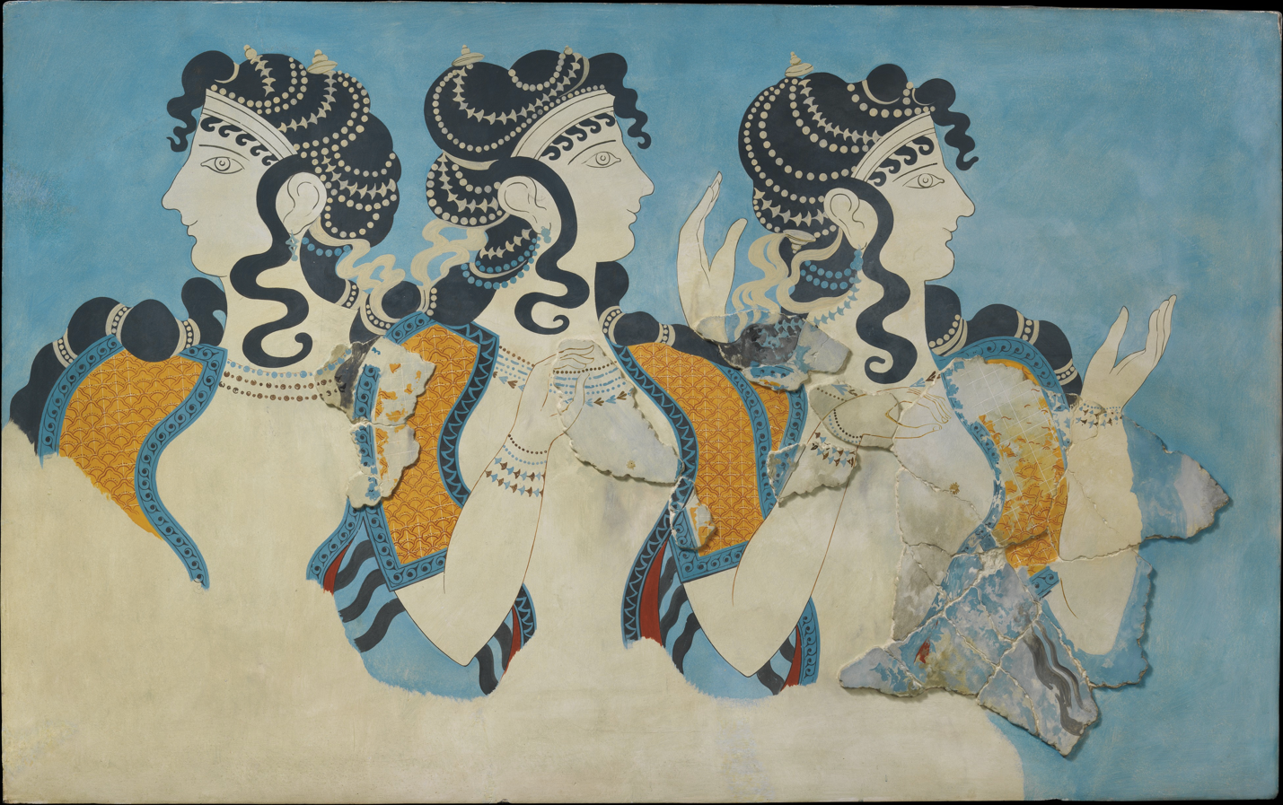

‘Ladies in Blue’ Fresco - 1525 - 1450BCE Excavated before 1914 from Knossos Palace

1. *Tick* **one (1)** of the following in (a) and (b) to best describe **Source 1.**  **(1 marks)**
   * + 1. written source ☐
       2. archaeological source ☐
       3. map/diagram ☐
       4. reconstruction ☐
2. *Identify* and *discuss* the **historical context** of **Source 1**. You should consider the following where appropriate: relevant event/s, significant person/people, key idea/s depicted in the source. **(4 marks)**

_____________________________________________________________________________________________________________________________________________________________________________________________________________________________________________________________________________________________________________________________________________________________________________________________________________________________________________________________________________________________________________________________________________________________________________________________________________________________________________________________________________________________________________________

**Source 2**

Minoan Art Labrys pithos – 1500BC Knossos Palace

1. *Tick* **one (1)** of the following in (a) and (b) to best describe **Source 1.**  **(1 marks)**
   * + 1. written source ☐
       2. archaeological source ☐
       3. map/diagram ☐
       4. reconstruction ☐
2. *Identify* and *discuss* the **historical context** of **Source 1**. You should consider the following where appropriate: relevant event/s, significant person/people, key idea/s depicted in the source. **(4 marks)**

____________________________________________________________________________________________________________________________________________________________________________________________________________________________________________________________________________________________________________________________________________________________________________________________________________________________________________________________________________________________________________________________________________________________________________________________________________________________________________________________________________________________________________________________________________________________________________________________________________________________________________________________________________________________________________________________________________________________

**Source 3**

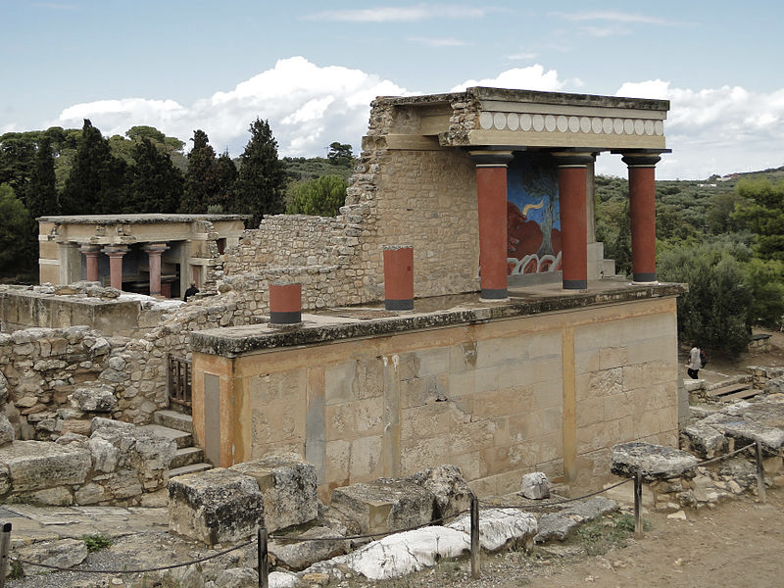

Knossos Palace - Restored North Entrance with charging bull fresco

1. *Tick* **one (1)** of the following in (a) and (b) to best describe **Source 1.**  **(1 marks)**
   * + 1. written source ☐
       2. archaeological source ☐
       3. map/diagram ☐
       4. reconstruction ☐
2. *Identify* and *discuss* the **historical context** of **Source 1**. You should consider the following where appropriate: relevant event/s, significant person/people, key idea/s depicted in the source. **(4 marks)**

_______________________________________________________________________________________________________________________________________________________________________________________________________________________________________________________________________________________________________________________________________________________________________________________________________________________________________________________________________________________________________________________________________________________________________________________________________________________________________________________________________________________________________________________________________________________________________________________________________________________________________________________________________________

**Source 4**

Bull-leaping fresco from the palace at Knossos

1. *Tick* **one (1)** of the following in (a) and (b) to best describe **Source 1.**  **(1 marks)**
   * + 1. written source ☐
       2. archaeological source ☐
       3. map/diagram ☐
       4. reconstruction ☐
2. *Identify* and *discuss* the **historical context** of **Source 1**. You should consider the following where appropriate: relevant event/s, significant person/people, key idea/s depicted in the source. **(4 marks)**

_______________________________________________________________________________________________________________________________________________________________________________________________________________________________________________________________________________________________________________________________________________________________________________________________________________________________________________________________________________________________________________________________________________________________________________________________________________________________________________________________________________________________________________________________________________________________________________________________________________________________________________________________________________

MARKING KEY

Student’s work being marked:_____________________________

Marker name:_______________________________________

1. *Tick* **one (1)** of the following in (a) and (b) to best describe **the source.**  **(1 marks)**

|  |  |  |
| --- | --- | --- |
| Source 1 | Archaeological | /1 mark |
| Source 2 | Archaeological | /1 mark |
| Source 3 | Reconstruction/ Archaeological | /1 mark |
| Source 4 | Archaeological | /1 mark |

1. *Identify* and *discuss* the **historical context** of **Source 1**. You should consider the following where appropriate: relevant event/s, significant person/people, key idea/s depicted in the source. **(4 marks)**

|  |  |
| --- | --- |
| **Description** | **Marks** |
| Accurately identifies and discusses the historical context of the source, demonstrating a sound historical knowledge of the period. The answer includes discussion of: relevant event/s and significant person/people and key idea/s | 4 |
| Identifies and briefly discusses the historical context of the source, demonstrating some historical knowledge of the period, but with omissions. The answer includes discussion of: relevant event/s AND/OR significant person/people AND/OR key idea/s | 3 |
| Identifies and provides a simple description the historical context of Source 1, demonstrating a limited historical knowledge of the period. The answer includes discussion of: relevant event/s AND/OR significant person/people AND/OR key idea/s | 2 |
| The answer demonstrates little historical knowledge of the period, with very simple description of: One (or two) of the criteria mentioned OR t he answer is factually inaccurate, or the answer simply describes the source | 1 |

|  |  |  |  |
| --- | --- | --- | --- |
| Source 1 | Source 2 | Source 3 | Source 4 |
| Importance of women in society  Social Roles/hierarchy  Equal between sexes  Gods AND goddesses worshipped | No people depicted but shows importance of war/weaponry with labrys  Labrys used in society  Agricultural society - wheat | Palace at Knossos home of king minos – ruler of Minoans  Significance of bull  Palaces as centre of society  Palace as status symbol | Roles of men and women in society  Significance of bull  Myth of minotaur  Rituals in society |